Unit I
Properties of Bulk material
Part i: Mechanical Properties of Solids: Elastic behaviour, Stress-strain relationship, Hooke’s law, Young’s modulus, bulk modulus, shear modulus of rigidity, Poisson’s ratio; elastic energy.
Part II: Mechanical Properties of Fluids: Pressure due to a fluid column; Pascal’s law and its applications (hydraulic lift and hydraulic brakes), the effect of gravity on fluid pressure. Viscosity, Stokes’ law, terminal velocity, streamline and turbulent flow, critical velocity, Bernoulli’s theorem and its applications. Surface energy and surface tension, angle of contact, excess of pressure across a curved surface, application of surface tension ideas to drops, bubbles and capillary rise.
Part III: Thermal properties of Matter: Heat, temperature, thermal expansion; thermal expansion of solids, liquids and gases, anomalous expansion of water; specific heat capacity; Cp, Cv – calorimetry; change of state – latent heat capacity.

Unit 1 Part 1
Properties of matter
Matter: Matter has many definitions, but the most common is that it is any substance which has mass and occupies space. Matter has many properties which we are going to discuss later in the chapter.

Elasticity
Elasticity, plasticity and rigidity
- When a force is applied on a body, and size and shape of the body changes, the body is said to be deformed.
- Under deformed condition, the internal force is developed which tries to restore the original size and shape of a body called as Internal restoring force.
- Because of this internal restoring force body regains its size and shape on removal of external deforming force.

Elasticity: The property on account of which a body regains its original shape and size on removal of external deforming force is called as elasticity.
Eg.
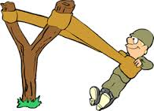

Elastic body: the body which regains its original size and shape on removal of external deforming force is called elastic body.
e.g. almost all metals - steel, brass, rubber, copper

Perfectly elastic body: some bodies which exactly regain their original dimension on removal of external deforming forces are called perfectly elastic bodies.
e.g.: quartz

Plasticity: The property on account of which a body easily deforms and does not regain its original size and shape on removal of external deforming force is called plasticity, i.e. material undergo permanent deformation.

Plastic bodies: Plastic bodies are the bodies which do not oppose the change in size and shape and get deformed very easily. They do not gain the original size and shape after the deforming force is removed.
e.g.: clay, putty, chalk.
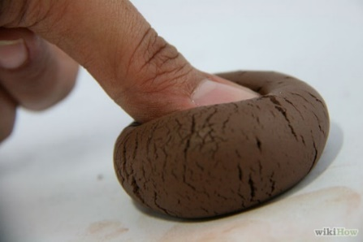

Rigidity: The property on account of which a body does not change size and shape even when a large force is applied on it, is called as rigidity.

Rigid body: A body in which it is not possible to produce any relative displacement of the different particles inside it and hence size and shape of a body remains unchanged even after large force is applied on it, is called as rigid body.
No body is perfectly rigid but STONE is taken as a rigid body.

Deforming force: The force applied on elastic body which is responsible to deform (change size and shape of the body) is called as deforming force.
Deformation α Deforming force

Internal restoring force: The force which is responsible to restore the original size and shape of the body is called as internal restoring force.
Applied force = Internal restoring force

Elastic Limit: Elastic limit is the maximum extent to which a solid may be stretched without permanent alteration of size or shape.

Related Questions

- Define: Restoring force, Deforming force.
- What is elasticity and elastic body?
- What is plasticity and plastic body?
- Distinguish between elastic bodies and plastic bodies? (only two points)
- Define elasticity and plasticity. Divide the following objects into two groups as elastic and plastic bodies: paper, steel, chalk, rubber, copper.
- Define rigidity.

Factors affecting elasticity
For a material elasticity remains constant, but following are the factors which affect elasticity,
- Effect of Temperature: in most of the cases, as the temperature of the material increases, elasticity decreases and vice versa. As the temperature increases the distance between the molecules increases hence intramolecular
- Effect of annealing: In the process of annealing the metal is heated and then cooled gradually. Due to annealing the smaller crystals present inside the material get oriented in one particular direction and formation of large crystal grains take place. Thus plasticity increases and elasticity decreases.

- Effect of hammering and rolling the material: The metal with smaller grains are stronger than those with larger grains. Due to hammering and rolling the crystal grains break up into smaller units which increases the elastic properties of the material. Thus hammering and rolling increases the elasticity and decreases the plasticity.

- Effect of impurities: The elastic properties are strengthened by adding impurities to the metal.
e.g. to strengthen the elastic properties, some amount of potassium in gold is added and some amount of molten steel is added.

- Effect of recurring stress: If repeated stress is applied on the same body then softening of material takes place and increases the plasticity and hence decreases the elasticity.

Related questions

- State the factors affecting elasticity of material.
- What is the effect of temperature on elasticity of material?
- What is the effect of annealing on elasticity of material?
- What is the effect of hammering and rolling on elasticity of material?
- What is the effect of addition of impurity on elasticity of material?
- What is the effect of recurring stress on elasticity of material?

Stress & its types
Stress is defined as internal elastic restoring force per unit cross-sectional area of the body
i.e. Stress = $\frac{Internal elastic restoring force}{Cross-sectional area}$
but, Restoring force = Applied force

Thus stress can be defined as applied force per unit cross-sectional area of a body.
Therefore, Stress = $\frac{Applied force}{Cross-sectional area}$

Thus, Stress = $\frac{Internal elastic restoring force}{Cross-sectional area}=$ $\frac{Applied force}{Cross-sectional area}$

Stress = $\frac{F}{A}$
MKS or SI unit of stress is N/ m² or (Pa) pascal.
CGS unit of stress is dyne/ cm².
The dimension of stress are [M¹ L⁻¹ T⁻²].

Types of stress
- Tensile stress or Longitudinal stress.
- Compressive stress or volumetric stress or volume stress.
- Shearing stress or Shear stress.

- Tensile stress or Longitudinal stress:
The stress that tends to change the length of the body is called tensile stress or Longitudinal stress.
Tensile Stress = $\frac{Applied force}{Cross-sectional area}$

= $\frac{F}{A}$

= $\frac{Mg}{Πr}$2 (where r is the radius of the wire)

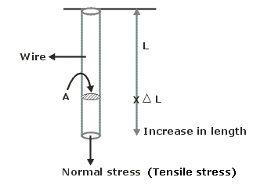
Figure. 1

MKS unit of tensile stress is N/ m².
CGS unit of tensile stress is dyne/ cm².
Dimension of tensile stress is [M1 L⁻¹ T⁻²]
Examples: rope climbing, bicycle chain, cables of lift elevator.

- Compressive stress or volumetric stress or volume stress:
Compressive stress: The stress which compresses the given body is called compressive stress.
Here shape of the body remains the same.

Volume stress or volumetric stress: The stress which changes volume of the body is called volume stress.
Volume stress = $\frac{Applied force}{Area}$

= change in pressure

= dp
MKS unit of tensile stress is N/ m².
CGS unit of tensile stress is dyne/ cm².
Dimension of tensile stress is [M1 L⁻¹ T⁻²]
Examples: piston, shock absorbers.

Shear stress:
Consider a metal block as shown, whose base is fixed. A tangential force ‘F’ is applied to the top surface as shown.
The block gets twisted (shape changes) and when equilibrium is reached, it takes the shape of parallelepiped.
Base
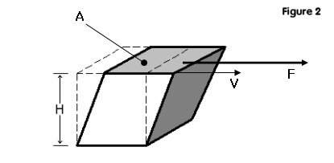

Definition: the tangential force per unit area of the surface is called shear stress.
Shear stress = $\frac{Tangential force}{Area of surface}$
= $\frac{F}{A}$

MKS unit of tensile stress is N/ m².
CGS unit of tensile stress is dyne/ cm².
Dimension of tensile stress is [M1 L⁻¹ T⁻²]
Examples: bone fracture because of bending, torsional pendulum, metal sheet cutter.

Related questions

- State SI unit of stress?
- Define stress?
- State types of stresses. State SI unit of stress.

Strain & its types
The amount of change in size or shape of material per unit original size or shape is called strain.
OR
Strain is the ratio of change in dimensions to the original dimensions of the body.
Strain = $\frac{Change in dimension}{Original dimension}$
Since strain is the ratio of two similar quantities, it has no unit.
Strain is a pure number.

Types of strain: strain is of three types which are as under
- Tensile strain or longitudinal strain or linear strain.
- Volume or volumetric or compressive strain.
- Shear strain.

- Tensile strain or longitudinal strain or linear strain:
Tensile strain is defined as the ratio of change in length to the original length.

Tensile Strain = $\frac{Change (increase) in length}{Original length}$

Tensile Strain = $\frac{New length-Original length}{Original length}$

Tensile Strain = $\frac{l}{L}$
It has no unit.

- Volume Strain:
Volume strain is defined as the ratio of change in volume to the original volume of a body.

Volume Strain = $\frac{Change in volume}{Original volume}$

Volume Strain = $\frac{dv}{V}$

It has no unit.

- Shearing Strain:

If the applied force produces change in shape of a body then the corresponding strain produced is the shearing strain. The cube is converted into parallelepiped.
Base


A
A’

Definition: Shearing strain is defined as the ratio of lateral displacement of any layer to its distance from the fixed layer.

D

Shearing Strain = $\frac{Lateral displacement of any layer}{its distance from the fixed layer}$

Shearing Strain = $\frac{Lateral displacement of upper layer}{its distance from the fixed layer}$

Shearing Strain = $\frac{AA'}{AD}$

Shearing Strain = tan θ
But even when a large tangential force is applied on a metal cube it gets deformed very little i.e. ‘θ’ is very small.
Therefore mathematically, tan θ = θ
Shearing strain = θ
Related questions

- Define strain?
- State and explain three types of strain.
- What is the unit of strain?

Elastic limit & Hooke’s law
Elastic limit: the stress corresponding to the limiting value of the load, which when applied and subsequently released, does not produce permanent deformation is called elastic limit.

Hooke’s Law: It states that, within elastic limit, stress is stress is directly proportional to strain.
Stress α Strain
Stress = Constant x Strain
The constant of proportionality is called as modulus of elasticity.
Thererfore, Modulus of elasticity = $\frac{Stress}{Strain}$
SI unit of modulus of elasticity is N / m².
CGS unit is Dyne / cm².
Dimensions of modulus of elasticity are [M¹ L⁻¹ T⁻²].

Related questions

- State Hooke’s law of elasticity?
- Define elastic limit.
- State and explain Hooke’s law of elasticity. Hence define elastic limit.
- State Hooke’s law of elasticity and define elastic limit.

Types of modulus of elasticity
As we have seen that when a force is applied on a body, then its length changes or volume changes or shape of the body changes. Accordingly, there are three types of modulus of elasticity.

- Young’s modulus of Elasticity
Within the elastic limit, the ratio of tensile stress to tensile strain is called Young’s modulus of elasticity ‘Y’.
Young’s modulus of elasticity measures the opposition offered by material for its change in length.

L = original length

l = increase in length
M

Y = $\frac{Tensile Stress}{Tensile Strain}$

Y = $\frac{F/A}{l/L}$ = $\frac{Mg/Πr2}{l/L}$

Y = $\frac{MgL}{Πr2l}$
Where,
M = load attached
r = radius of wire
L = original length of wire
l = extension produced

SI unit of modulus of elasticity is N / m².
CGS unit is Dyne / cm².
Dimensions of modulus of elasticity are [M¹ L⁻¹ T⁻²].

- Bulk modulus of Elasticity (K)
Within elastic limit, the ratio of volume stress to volume strain is called bulk modulus of elasticity ‘K’.
Bulk modulus of elasticity measures the opposition offered by material for its change in volume.
Force
dv

V

Bulk modulus of elasticity,
K = $\frac{Volume Stress}{Volume Strain}$
K = $\frac{F/A}{dv/V}$
K = $\frac{dp}{dv/V}$
K = $\frac{dp V}{dv}$
Where,
V = original volume
F = applied force
dv = decrease in volume
dp = increase in pressure
A = area of cross section on which force applied

SI unit of modulus of elasticity is N / m².
CGS unit is Dyne / cm².
Dimensions of modulus of elasticity are [M¹ L⁻¹ T⁻²].

Compressibility: The property on account of which a body can be compressed by the application of external force is called compressibility i.e. it is the ability to compress.
The reciprocal of bulk modulus of elasticity is called compressibility.
Compressibility = $\frac{1}{Bulk Modulus}$
= $\frac{1}{K}$ = $\frac{1}{\frac{dp}{dv} x V}$ = $\frac{dv}{dp . V}$
Compressibility represents strain per unit stress.
Compressibility = $\frac{Volume strain}{Volume stress}$

SI unit of Compressibility is m² / N
CGS unit is cm² / Dyne
Dimensions of Compressibility are [M⁻¹ L¹ T²].

- Modulus of Rigidity (η)
Within elastic limit, the ratio of shearing stress to shearing strain is called modulus of rigidity.
Modulus of rigidity measures the opposition offered by material for its change in shape.


Modulus of rigidity,
η = $\frac{Shearing Stress}{Shearing Strain}$
η = $\frac{F/A}{\frac{Lateral displacement of layer}{\left(its distance from fixed layer\right)} }$
η = $\frac{F/A}{{AA}^{'}/AD}$
η = $\frac{F/A}{\tan{θ}}$
if $θ$ is small put tan $θ$ = $θ$,
therefore η = $\frac{F}{Aθ}$ (refer shearing strain above for the formula)
where,
F = tangential force
A = area on which force is applied

SI unit of Modulus of rigidity is N / m².
CGS unit is Dyne / cm².
Dimensions of Modulus of rigidity are [M¹ L⁻¹ T⁻²].

Relation between Y, K, and η:
For a given material, there is certain relation between Y, K, and η which is given by,
Y = $\frac{9ηK}{3K + η}$

$\frac{1}{Y}$= $\frac{1}{3η}$ + $\frac{1}{9K}$
Where,
Y = Young’s modulus of elasticity.
K = Bulk modulus.
η = Modulus of rigidity.

Related questions

- Define: Young’s modulus, Bulk modulus, modulus of rigidity. Give relation between them.
- Write the SI unit of all the three modulus.

Poisson's Ratio
As load is applied to a material, the material elongates and the cross-sectional area is reduced. This reduction in cross-sectional area is called lateral strain, and it is related to the axial strain by Poisson's ratio, ν. For a circular specimen this reduction in area is realized as a reduction in diameter, and the Poisson's ratio is calculated as:
Poisson's Ratio ν = Transverse/Lateral strain/Axial strain

Stress-Strain Curve
The values of stress and strain determined from the tensile test can be plotted as a stress-strain curve, as shown below:

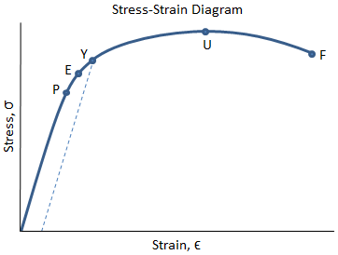

There are several points of interest in the diagram above:
- P: This is the proportionality limit, which represents the maximum value of stress at which the stress-strain curve is linear.
- E: This is the elastic limit, which represents the maximum value of stress at which there is no permanent set. Even though the curve is not linear between the proportionality limit and the elastic limit, the material is still elastic in this region and if the load is removed at or below this point the specimen will return to its original length.
- Y: This is the yield point, which represents the value of stress above which the strain will begin to increase rapidly. The stress at the yield point is called the yield strength, S_{ty}. For materials without a well-defined yield point, it is typically defined using the 0.2% offset method in which a line parallel to the linear portion of the curve is drawn that intersects the x-axis at a strain value of 0.002. The point at which the line intersects the stress-strain curve is designated as the yield point.
- U: This point corresponds to the ultimate strength, S_{tu}, which is the maximum value of stress on the stress-strain diagram. The ultimate strength is also referred to as the tensile strength. After reaching the ultimate stress, specimens of ductile materials will exhibit necking, in which the cross-sectional area in a localized region of the specimen reduces significantly.
- F: This is the fracture point or the break point, which is the point at which the material fails and separates into two pieces.
There are four basic mechanical properties which can be compared with stress strain curve
- Strength of the material: Strength refers to a material's ability to carry a load.
- Toughness of the material: Toughness is the ability of a material to absorb energy up to fracture.
- Brittleness of material: A material is brittle if it fractures at low strains with little or no plastic deformation.
- Ductility of material: Ductility is a measure of the ability of a material to deform plastically before fracturing.
https:/ /www.youtube.com/watch?v=eNPRa_3mOIM
Types of strength in material

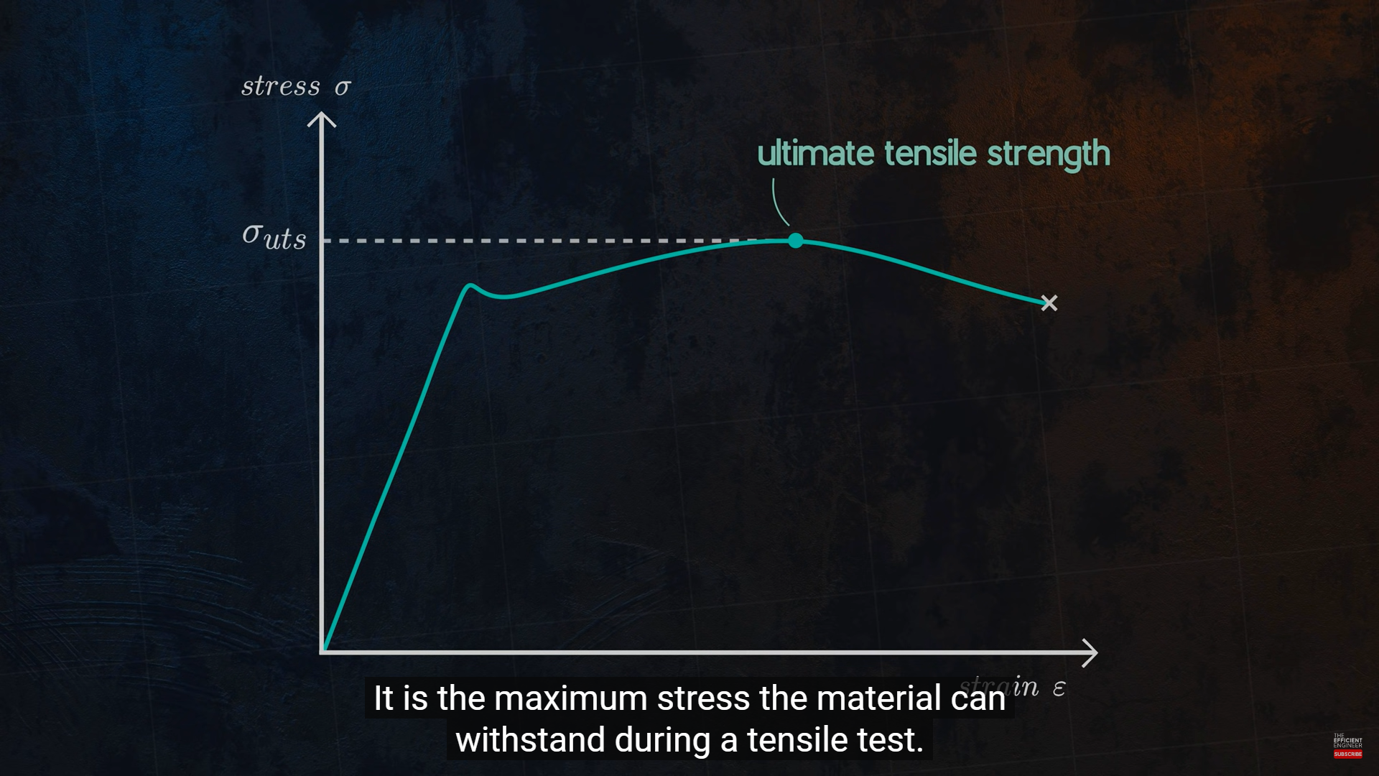

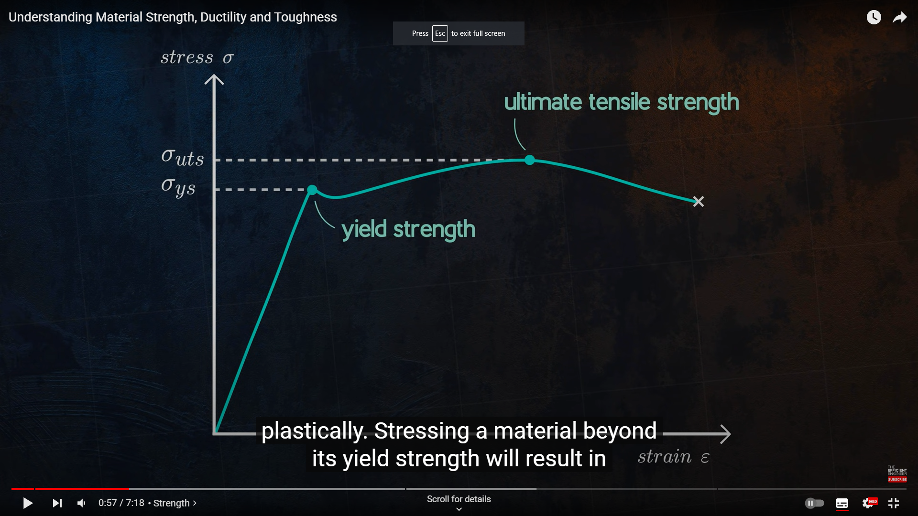
Stress Strain curve for brittle and tensile material
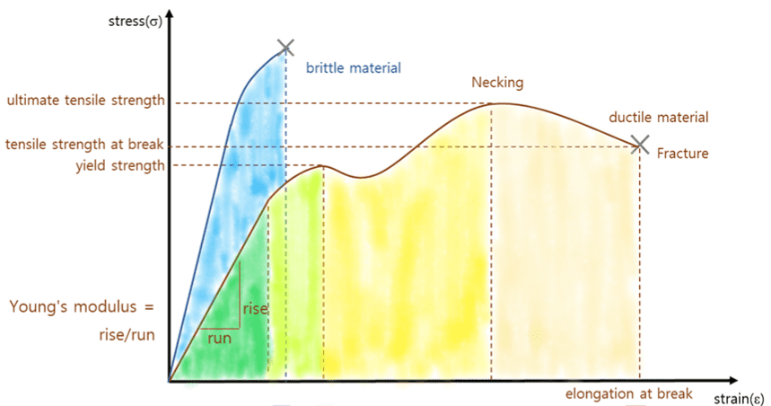

Stress strain curve to show toughness of a material; .
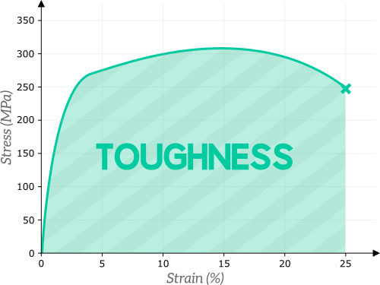
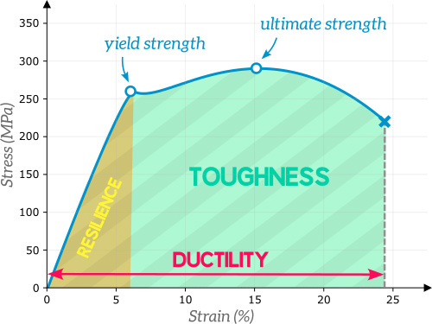

UNIT 1 Part II
PROPERTIES OF LIQUIDS
Content
- Fluid Friction: Pressure, Pressure depth relation (P=ρh g), atmospheric pressure Pascal’s law, Archimedes’ principle Up -thrust force.
- Viscous force: Definition of viscosity, velocity gradient, Newton’s law of viscosity, coefficient of viscosity and its SI unit, streamline and turbulent flow with examples, critical velocity, Reynolds’ number and its significance. Terminal velocity, stokes law and determination of coefficient of viscosity by Stokes law, effect of temperature and adulteration on viscosity of liquid.
- Surface tension: Cohesive and adhesive force, Laplace’s molecular theory of surface tension, surface tension; definition and unit, effect of temperature on surface tension, Angle of contact, capillarity and examples of capillary action, derivation of expression for surface tension by capillary rise method, applications of surface tension.

Introduction
Based on intermolecular forces, the three state of Matter (solid, liquid and gas) can be compared as follows
Solid | Liquid | Gases
The intermolecular distance is small and fixed. | The intermolecular distance is more and not fixed. | The intermolecular distance is large and not fixed.
Intermolecular force is stronger in case of solids, hence it is not easy to change the size and shape of the body. | Intermolecular molecular forces are comparatively weaker than solids, hence shape of liquid can be changed but its size (volume) of the liquid is not so easy to change. | Intermolecular molecular forces are very weak, hence it is easy to change shape of and volume of gases.
Large force is required to change size and shape of a solid body. | Liquid needs appreciable force (pressure) to change its volume.
Liquid and gases together are termed as fluids since they are able to flow.

  - Fluid Friction:
Pressure:
Definition: The force per unit area is called pressure. In case of liquids, the force is defined as thrust. (The total force exerted by a liquid on a surface in contact is called thrust of a liquid).
So now the specific definition for pressure in case of liquid is: The thrust by a liquid (at rest) per unit area on the surface in contact with the liquid is called liquid pressure. If F is thrust and A is surface area than pressure P can be defined as
P=F/A.
- When Liquid is in equilibrium, the pressure of a liquid always act normal (perpendicular) to the surface.
- Pressure acts in all directions.
- Pressure acting on a liquid at rest will be transmitted equally in all directions.

The S. I. Unit of pressure is N/m² i.e. pascal (Pa).
The C. g. s. unit of pressure is Dyne /cm².
1N/m²=1Pa=10dyne/cm²
The dimensions of pressure are [M ¹ L ⁻¹ T ⁻² ].
Examples of pressure:
- Garden Hose
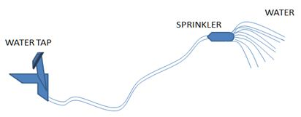
Garden hose is a flexible pipe attached with a sprinkler at one end. When the water is supplied from the other end, water will pass through the pipe and then through the sprinkler. It can be observed that water spreads with equal force in all directions. The liquid pressure acts in all directions.
Liquid pressure increases with depth.
2. Hydraulic pump (oil).
3. Toy balloon inflates because of air pressure inside.
4. Sucking a drink through a straw - fluid flows because of pressure difference.
5. Nails with pointed tip can penetrate in the wall. Etc.

Pressure Depth Relation:
While swimming we experience more pressure as we go in the downward direction. When fluid (liquid) is taken in a vessel, it exerts pressure on the walls and base of the vessel. A liquid pressure is due to its own weight. This liquid pressure at any point depends on the depth of liquid. Consider a vessel containing liquid of density’ ρ’. The liquid exerts pressure on all sides and base of the vessel. Consider any point ‘X’ inside the liquid. Consider the unit area around the point “X”. Draw imaginary cylinder above the point ‘X’ upto the free surface of the liquid.
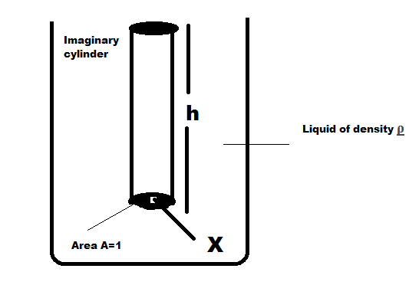
Let, A=1=unit area around the point ‘X’
H = Height of the cylinder
= Depth of the point ‘X’ from free surface
= Pressure (static) head

ρ = Density of the liquid
= pressure at point ‘X’
Downward force:
Now, on unit area, weight of the liquid inside the cylinder around the point ‘X’
i.e. Pressure at point ‘X’’ =[mass of liquid in the cylinder]×g
= [(A×h)×ρ]×g
= [1×h×ρ×g]
Thus, Pressure at point ‘X’ P=hρg
Thus h, ρ, and g are the factors on which pressure at a point in a liquid depends.
Some important facts on which pressure depends:
- Pressure at a point inside the liquid depends on the depth. Pressure increases with depth.
- Pressure at any point inside the liquid is same in all directions.
- There is equal pressure at all the points which are in the same level.

Atmospheric pressure:
Definition: The pressure exerted by the atmosphere is called atmospheric pressure. Or the atmospheric pressure at a point is the weight of the air column of unit cross sectional area and height extending upto top of the atmosphere. Thus atmospheric pressure is maximum at earth’s surface.
The standard atmospheric pressure at sea level corresponds to 76 cm of height of mercury column, which is called as 1 atmospheric pressure. This is also called normal atmospheric pressure.
1 atmospheric pressure = 1 atm= pressure exerted by 76 cm of mercury column. But
P=hρg
1atm = (0.76 m)×(13.6 ×10³ kg/m³) (9.8 m/s²)
1 atm = 1.013×10⁵ N/m² or Pascal (Pa)
=1.013 bar=1.013×10⁶ dyne/cm² (1 bar =10⁵ Pa)

How to measure atmospheric pressure: Atmospheric pressure is measured with the help of instrument called barometer. The barometer is a glass tube consisting of mercury inside it. This tube is kept in vertical position. Its top end is open and bottom end is closed with the help of small leather bag as shown.
If the atmospheric pressure is more, then this leather bag gets compressed and mercury inside the tube depresses down.
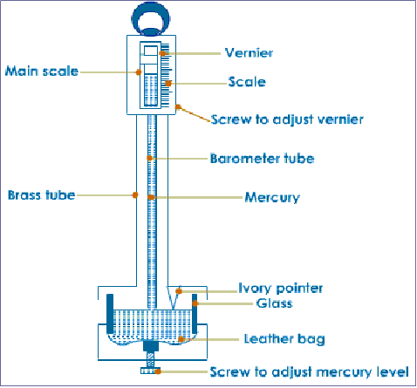
This tube is calibrated in terms of cm. Hence the atmospheric pressure is measured in terms of cm of Hg.

Pascal’s law:
Definition: Pascal's law states that when there is an increase in pressure at any point in a confined fluid, there is an equal increase at every other point in the container.
This change in pressure acts normal to the surface everywhere.
A container, as shown below, contains a fluid. There is an increase in pressure as the length of the column of liquid increases, due to the increased mass of the fluid above.
For example, in the figure below, P3 would be the highest value of the three pressure readings, because it has the highest level of fluid above it. If the above container had an increase in overall pressure, that same added pressure would affect each of the gauges (and the liquid throughout) the same. For example P1, P2, P3 were originally 1, 3, 5 units of pressure, and 5 units of pressure were added to the system, the new readings would be 6, 8, and 10.
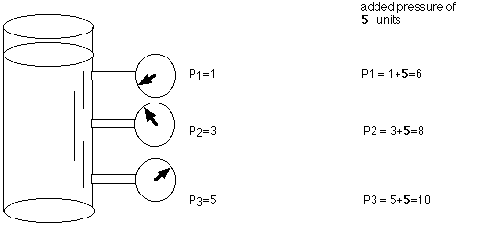
Applied to a more complex system below, such as a hydraulic car lift, Pascal's law allows forces to be multiplied. The cylinder on the left shows a cross-section area of 1 square inch, while the cylinder on the right shows a cross-section area of 10 square inches. The cylinder on the left has a weight (force) on 1 pound acting downward on the piston, which lowers the fluid 10 inches. As a result of this force, the piston on the right lifts a 10 pound weight a distance of 1 inch.

The formulas that relate to this are shown below:
P1 = P2 (since the pressures are equal throughout).
Since pressure equals force per unit area, then it follows that
F1/A1 = F2/A2
It can be shown by substitution that the values shown above are correct,
1 pound / 1 square inches = 10 pounds / 10 square inches
Because the volume of fluid pushed down on the left side equals the volume of fluid that is lifted up on the right side, the following formula is also true.
V1 = V2
by substitution,
A1 D1 = A2 D2
- A = cross sectional area
- D = the distance moved
A1/A2= D2/D1
This system can be thought of as a simple machine (lever), since force is multiplied. The mechanical advantage can be found by rearranging terms in the above equation to
Mechanical Advantage (IMA) = D1/D2 = A2/A1
For the sample problem above, the IMA would be 10:1 (10 inches/ 1 inch or 10 square inches / 1 square inch).
Examples (Application):
- Hydraulic lift (jack) : In this case force is magnified to lift heavy objects .
- Hydraulic press: To compress metal sheets.
- Hydraulic breaks: used in cars and buses.
Archimedes Principle:
Before starting with Archimedes principle one should know up thrust or buoyant force. In science, buoyancy (also known as upthrust) is an upward force exerted by a fluid that opposes the weight of an immersed object. In a column of fluid, pressure increases with depth as a result of the weight of the overlying fluid.
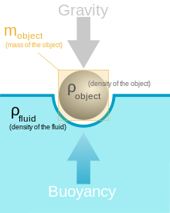


Example to explain upthrust of Buoyancy: It is quite difficult to uplift a person of weight 70kg in air. But it is comparatively easy to lift the same person in water. Because liquid is helping us to lift the person. i.e. liquid exert upward force.
Archimedes Principle statement: This principle states that when a solid insoluble body is immersed completely or partly in a liquid, it loses its weight and loss weight of the body id equal to the weight of displaced liquid.
Loss of weight=Magnitude of Buoyant force
[Actual weight]-[Apparent weight]=[Magnitude of Buoyant force]
W_{in air} –W_{in water} =volume of displaced liquid × density of liquid × g
= (V _{dis} × ρ _{(liq.)} ) × g
If the body is floating then
Weight of body= weight of displaced liquid
If a body is floating then $\frac{V(displaced)}{V(solid)}=\frac{ρ(solid)}{ρ(Liquid)}$
Where
V (displaced) = volume of a liquid displaced
= Volume of a body inside the liquid
V (solid) = Volume of solid.
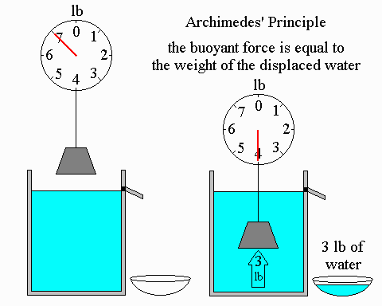

Example or applications:
- The ship would sink to a certain level until its weight is equal to the buoyant force.
- The submarine can submerge to a depth where the buoyant to a depth where the buoyant
force is equal to its weight.
- Hot air balloon.

Numerical :
The maximum thrust exerted by a hydraulic ram is 40 N. The pressure of the liquid is 20 N/m². Calculate the required diameter of the ram. (D=1.596 m)
- Calculate the pressure of water at depth of 20 m inside the water. (P=1.96 × 10⁵ N/m²)
- A solid floats on water in a water tank. What fraction of volume of ice will be below the water surface? (Density of ice = 0.93 gm/cm³) (Fraction of volume below the water surface = 0.93)

4.2 Viscosity
Definition: Viscosity is the property of liquid on account of which liquid tries to oppose the relative motion between its different layers.
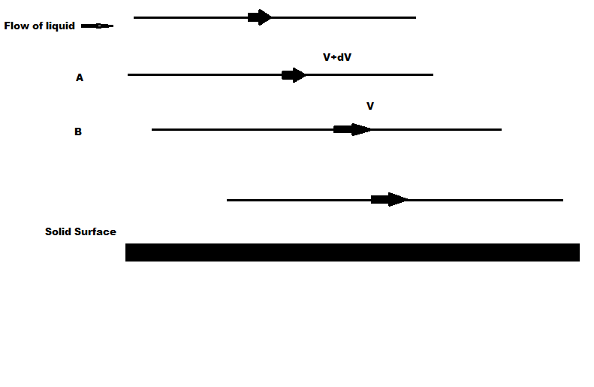
Explanation: Consider layer A and B. Layer A which has more speed, tries to accelerate layer B. At the same time, layer B which has less speed, tries to decrease speed of layer A and thus because of different tendencies of different layers, a frictional force (fluid friction) is created between two layers called as viscous force which tries to oppose the relative motion between different layers i.e. tries to reduce the difference between their speeds called viscosity.
Velocity Gradient (Definition):- Velocity gradient is defined as the change in velocity per unit change (vertical) in distance of liquid layers.
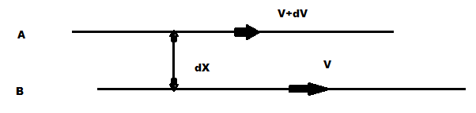
Velocity gradient =$\frac{dV}{dx}$
Unit of velocity gradient is per second i.e. 1/sec.
Newton’s Law of viscosity:-
Newton’s Law of viscosity states that the force ‘F’ developed between two liquid layers is
- Directly proportional to the surface area ‘A’ of liquid layer,
- Directly proportional to the velocity gradient.
Thus,
F$∝$ A
And F $∝$ $\frac{dV}{dx}$
By combining
F $∝$ $\frac{dV}{dx}×A$
F = $\frac{dV}{dx}×A η$
Where $η$ is called coefficient of viscosity, $η$ is constant for a given liquid. It changes from liquid to liquid.
Definition of coefficient of viscosity:
Coefficient of viscosity $η$of a liquid is defined as the viscous force developed between two liquid layers of unit surface area for unit velocity gradient.
Mathematical formula of coefficient of viscosity $η=\frac{F}{\frac{dV}{dx}×A}$ i.e. $\frac{F \left(newton\right)}{\frac{dV}{dx}\left(\frac{\frac{m}{s}}{m}\right)×A \left(m^{2}\right)}$, =Ns/m² is the SI unit of $η.$
Or Dyne –s/cm² is the CGS unit of$η$, or 1 poise = 1 dyne-s/cm² = (1/10) Ns/m².
The coefficient of viscosity $η$is said to be 1 poise if 1 dyne viscous force is developed between two liquid layers of 1 cm² area for unit velocity gradient.
In order to define$η$, if A=1, $\frac{dV}{dx}=1$ then$η=F$.
Flow of liquid through a tube:
There are two types of flow found in liquids as Streamline or Laminar flow and Turbulent flow.
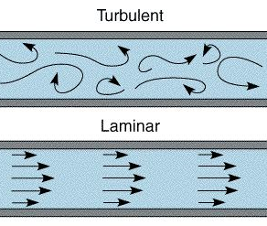
LAMINAR (STREAMLINE) FLOW

The flow separates into "layers" that slide relative to one another without mixing. If we introduce a coloured stream into the laminar flow, the colour will stay in the stream. The flow is called laminar flow or streamline flow.

Laminar flow can be represented by a set of lines known as streamlines (flow lines). An individual particle will follow a streamline. The flow pattern does not change with time. All particles starting on a streamline will continue to move on that streamline. A set of streamlines is called a flow tube. Streamlines can't cross nor intersect the "walls" of the flow tube.

The instantaneous velocity of the particle is in the direction of the tangent to the streamline. Density of streamlines proportional to the velocity:
Stream lines close together ⇒ high velocity
Stream line far apart ⇒ low velocity.

The flow remains streamline so long as the velocity is below certain velocity called critical velocity. For an ideal fluid, no kinetic energy of the particles is lost.

Example of streamline flow:
- Flow of river water in summer season is slow and steady i.e. streamline.
- A gently flowing water stream.

Definition of critical velocity: The value of velocity of flow of liquid upto which flow is streamline is called critical velocity ‘V_{c}’.

If velocity of flow of liquid increases and crosses critical velocity, then particle starts moving in the random direction i.e. flow becomes turbulent.

Thus, critical velocity is also defined as the velocity of flow of liquid at which streamline flow changes into turbulent flow.

TURBULENT FLOW

The flow of liquid in which every particle is not moving in line and they move in random directions is called turbulent flow. This happens when speed of flow of water is more than certain value (i.e. more than critical velocity).
Examples of turbulent flow:
- The flow of blood through a normal artery is laminar. However, when irregularities occur the flow becomes turbulent. The noise generated by the turbulent flow can be heard with a stethoscope.
- Water fall.
- Non steady flow as in tidal bore.

The velocity of liquid is directly proportional to the coefficient of viscosity (η), and inversely proportional to the density of the liquid (ρ) and radius (r) of the tube through which it is moving.
V$∝\frac{η}{ρr}$
On the basis of experiments, scientist Reynolds established that the nature of the flow depends upon a dimensionless quantity, which is now called the Reynolds number (R). The sign of proportionality can be replaced by that number. He observed that for a tube of radius 1 cm if R is less than 2000, then liquid flow is streamline, when if R is between 2000 to 3000 then the liquid flow is unstable and when R is greater than 3000, the liquid flow is turbulent.

Comparison between streamline flow and turbulent flow:

Streamline flow | Turbulent flow
- The flow of liquid in which every particle of the liquid moves inline of flow of liquid is called streamline flow. | - The flow of liquid in which every particle of the liquid moves in any random direction is called turbulent flow.
- This flow is steady. | - This flow is speedy.
- The velocity at every point within the liquid remains constant. | - The velocity at every at every point within the liquid is different.
- The velocity of flow of liquid is less than critical velocity. V<V_{c} | - The velocity of flow of liquid is more than critical velocity. V<V_{c}
- The value of Reynold’s number R is less than 2000.  R<2000 | - The value of Reynold’s number R is more than 3000.  R>3000
e.g.  - Flow of water during summer  - A gently flowing water stream. | e. g.  - Flow of water during flood.  - Water fall.

Bernoulli’s principle
Statement: The total mechanical energy of the moving fluid comprising the gravitational potential energy of elevation, the energy associated with the fluid pressure and the kinetic energy of the fluid motion, remains constant.
Bernoulli’s principle can be derived from the principle of conservation of energy.

Bernoulli’s Principle Formula
Bernoulli’s equation formula is a relation between pressure, kinetic energy, and gravitational potential energy of a fluid in a container.
The formula for Bernoulli’s principle is given as follows:
p1+1/2ρv₁²=p2+1/2ρv₂².

Bernoulli’s Principle Applications
The other applications of Bernoulli’s principle are:
- Venturi meter: It is a device that is based on Bernoulli’s theorem and is used for measuring the rate of flow of liquid through the pipes.
- Working of an aeroplane: The shape of the wings is such that the air passes at a higher speed over the upper surface than the lower surface. The difference in airspeed is calculated using Bernoulli’s principle to create a pressure difference.
- When we are standing at a railway station and a train comes we tend to fall towards the train. This can be explained using Bernoulli’s principle as the train goes past, the velocity of air between the train and us increases. Hence, from the equation, we can say that the pressure decreases. So the pressure from behind pushes us towards the train. This is based on Bernoulli’s effect.
- Bernoulli’s principle is used for studying the unsteady potential flow which is used in the theory of ocean surface waves and acoustics.
- It is also used for approximation of parameters like pressure and speed of the fluid.

Free Fall of spherical body through Viscous Medium and Stoke’s Law:
When a body falls under gravitation, through a column of liquid, different liquid layers move with different speeds. Liquid layers move with different speeds. Liquid layers which are in contact with the wall of container has zero velocity. Because of different speeds of different layers, a viscous force which opposes the relative motion is developed.
Practically, it is observed that after covering certain distance the body, which is freely falling, attains constant velocity called as terminal velocity.
Definition of terminal velocity: The constant velocity with which a body falls through liquid column is called terminal velocity.
Stoke’s law: Stokes law states that the force of viscosity experienced by a small metal sphere falling freely through a viscous medium, with terminal velocity id directly proportional to
- Radius of metal sphere ‘r’
- Terminal velocity ‘v’
- Coefficient of viscosity of liquid ‘η’
i.e. F$∝ηrv$
F = 6$π ηrv$

Derivation of viscosity by Stoke’s law:
Consider a metal sphere placed on the surface of liquid taken in glass jar. It is observed that after covering certain distance, metal sphere attains a constant velocity called terminal velocity.
Metal sphere falling freely through a liquid experiences three forces:
- Weight of the metal sphere in the downward direction.
- Force of viscosity in the upward direction.
- Upthrust force (force of buoyance) in the upward direction.
By Archimedes principle,
Upthrust force = loss of weight of body in liquid
= weight of displaced liquid
Since metal sphere falls with constant velocity, the total upward force is equal to the down ward force.
$∴$Total upward force = Downward force
$∴$ [force of viscosity ] +[ upthrust force] = [Weight of the metal sphere]
$∴$ [6πrηv] + [weight of displaced liquid ] = [Weight of the metal sphere]
$∴$ [6πrηv] +[(mass of displaced liquid ) × g] = [(mass of metal sphere ) × g ]
$∴$ [6πrηv] +[(volume of displaced liquid) (Density of liquid ) × g ] = [(volume of metal sphere) (Density of metal ) × g ]
$∴$ [6πrηv] + [($\frac{4πr3}{3}× ρ ×g$] = [($\frac{4πr3}{3}× d ×g$]
$∴$ [6πrηv] = $\frac{4}{3}π r^{3}g (d-g)$
V = $\frac{2}{9} \frac{r^{2 }g (d-ρ)}{η}$

With the above formula viscosity can be calculated in the laboratory.

Factors affecting viscosity:

Temperature
A fluid's viscosity strongly depends on its temperature. Along with the shear rate, temperature really is the dominating influence. The higher the temperature is, the lower a substance's viscosity is. Consequently, decreasing temperature causes an increase in viscosity.
The relationship between temperature and viscosity is inversely proportional for all substances.
A change in temperature always affects the viscosity – it depends on the substance just how much it is influenced by a temperature change. For some fluids a decrease of 1°C already causes a 10 % increase in viscosity.
Adulteration:
Liquid adulteration means mixing of some other material. Practically, it is observed that when adulteration of soluble substance is added to liquid, its viscosity goes on increasing.
Because of alteration, mobility of liquid decreases i.e. viscosity increases. E.g.
If sugar is dissolved in pure water then viscosity of net solution increases.
Numerical Questions
Q.1 With what terminal velocity will an air bubble of radius 0.1 cm rise through water? Coefficient of viscosity of water is 10⁻² poise. Neglect density of bubble. (218 cm/s)
Q.2 A spherical stell ball of radius 0.3 mm falls vertically through water. Find the coefficient of viscosity of water Given that the terminal velocity acquired by the ball is 9.8× 10⁻² m/s, density of water is 1× 10³ kg/m³ and density of the ball is 1.5× 10³ kg/m³. (1× 10⁻³ Ns/m³)
Q.3 Calculate the viscous force on raindrop of diameter 4 mm falling with a constant velocity of 4 m/s through air. Coefficient of viscosity of air is 1.8× 10⁻⁴ poise. (0.27 dyne)
Q.4 A liquid flows through a pipe of radius 4 cm with a speed of 12m/s. The density of liquid is 0.85× 10³ kg/m³ and coefficient of viscosity is 0.6 Ns/m³ . Determine Reynolds number and state whether the flow is turbulent or streamline. ( R=680 , which is less than 2000, hence flow is streamlined. )

4.3 Surface tension:
Before starting with the theory of surface tension we will go through some definition
Molecular forces: Intermolecular forces: The force of attraction or repulsion acting between the molecules are known as intermolecular force. The nature of intermolecular force is electromagnetic. The intermolecular forces of attraction may be classified into two types:
Cohesive force | Adhesive force
The force of attraction between molecules of same substance is called the force of cohesion. This force is lesser in liquids and least in gases.  - Two drops of a liquid coalesce into one when brought in mutual contact. | The force of attraction between the molecules of the different substances is called the force of adhesion.  - Adhesive force enables us to write on the Blackboard with a chalk..
- It is difficult to separate two sticky plates of glass welded with water. | - A piece of paper sticks to another due to large force of adhesion between the paper and gum molecules.
- It is difficult to break a drop of mercury into small droplets because of large cohesive force between the  Mercury molecules. | - Water wets the glass surface due to force of adhesion.

Cohesive or adhesive forces are inversely proportional to the eighth power of distance between the molecules.

Molecular range: The maximum distance upto which cohesive force can act is called as molecular range.

Sphere of influence: The imaginary sphere drawn with molecule as a centre and molecular range as a radius is called sphere of influence.
Surface Tension.
The property of a liquid due to which its free surface tries to have minimum surface area and behaves as if it were under tension somewhat like a stretched elastic membrane is called
surface tension. A small liquid drop has spherical shape, as due to surface tension the liquid surface tries to have minimum surface area and for a given volume, the sphere has minimum surface area. Surface tension of a liquid is measured by the force acting per unit length on either side of an imaginary line drawn on the free surface of liquid, the direction of this force being perpendicular to the line and tangential to the free surface of liquid. So if F is the force acting on one side of imaginary line of length L, then T = (F/L)

(1) It depends only on the nature of liquid and is independent of the area of surface or length of line considered.
(2) It is a scalar as it has a unique direction which is not to be specified.
(3) Dimension: [MT – 2]. (Similar to force constant)
(4) Units: N/m (S.I.) and Dyne/cm [C.G.S.]
(5) It is a molecular phenomenon and its root cause is the electromagnetic forces.
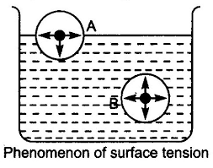

Laplace’s molecular theory of surface tension:

The maximum distance upto which the force of attraction between two molecules is appreciable is called molecular range ( 10 ) ⁹m.
A sphere with a molecule as centre and radius equal to molecular range is called the sphere of influence. The liquid enclosed between free surface (PQ) of the liquid and an imaginary plane (RS) at a distance r (equal to molecular range) from the free surface of the liquid form a liquid film.
Molecules below RS have no potential energy. But the molecules above line PQ possess potential energy due to their position. As the natural tendency to attain the position of minimum potential energy, these molecules are attracted downwards inside the liquid. As a result of this, the number of molecules on the surface of liquid come closer to each other and hence its surface area is reduced or surface of liquid contracts producing tension.
To understand the tension acting on the free surface of a liquid, let us consider four liquid molecules like A, B, C and D. Their sphere of influence are shown in the figure.

- Molecule A is well within the liquid, so it is attracted equally in all directions. Hence the net force on this molecule is zero and it moves freely inside the liquid.

- Molecule B is little below the free surface of the liquid and it is also attracted equally in all directions. Hence the resultant force on it is also zero.

- Molecule C is just below the upper surface of the liquid film and the part of its sphere
of influence is outside the free liquid surface. So the number of molecules in the upper half (attracting the molecules upward) is less than the number of molecule in the lower half (attracting the molecule downward). Thus the molecule C experiences a net downward force.
- Molecule D is just on the free surface of the liquid. The upper half of the sphere of
influence has no liquid molecule. Hence the molecule D experiences a maximum
downward force. Thus all molecules lying in surface film experiences a net downward force. Therefore, free surface of the liquid behaves like a stretched
membrane.
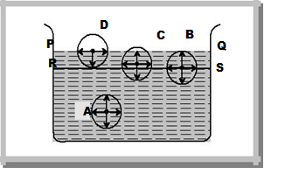
Factors Affecting Surface Tension.

- Temperature : The surface tension of liquid decreases with rise of temperature. The surface tension of liquid is zero at its boiling point and it vanishes at critical temperature. At critical temperature, intermolecular forces for liquid and gases becomes equal and liquid can expand without any restriction. For small temperature differences, the variation in surface tension with temperature is linear and is given by the relation

T_{t} = T₀ (1-αt)

where T_{t} and T₀ are the surface tensions at t⁰ C and 0 ºc respectively and  is the temperature coefficient of surface tension.

Examples :
(i) Hot soup tastes better than the cold soup.
(ii) Machinery parts get jammed in winter.

(2) Impurities: The presence of impurities either on the liquid surface or dissolved in it, considerably affect the force of surface tension, depending upon the degree of contamination. A highly soluble substance like sodium chloride when dissolved in water, increases the surface tension of water. But the sparingly soluble substances like phenol when dissolved in water, decreases the surface tension of water.

Applications of Surface Tension:-

1) The oil and grease spots on clothes cannot be removed by pure water. On the other hand, when detergents (like soap) are added in water, the surface tension of water decreases. As a result of this, wetting power of soap solution increases. Also the force of adhesion between soap solution and oil or grease on the clothes increases. Thus, oil, grease and dirt particles get mixed with soap solution easily. Hence clothes are washed easily.

(2) The antiseptics have very low value of surface tension. The low value of surface tension prevents the Formation of drops that may otherwise block the entrance to skin or a wound. Due to low surface tension, the antiseptics spreads properly over wound.

(3) Surface tension of all lubricating oils and paints is kept low so that they spread over a large area.

(4) Oil spreads over the surface of water because the surface tension of oil is less than the surface tension of cold water.

(5) A rough sea can be calmed by pouring oil on its surface.

(6) In soldering, addition of ‘flux’ reduces the surface tension of molten tin, hence, it spreads.

Angle of contact and its significance

Definition: The angle made by the tangent to the curved part of liquid surface at the point of contact with wall of a container measured through the liquid is called angle of contact θ.

S. I. Unit of angle of contact is θ is radian.

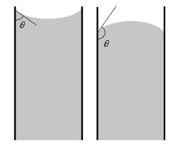

Factors affecting angle of contact: The angle of contact depends on nature of liquid and nature of solid. Also θ depends upon purity of liquid and cleanliness of solid. Thus for a given solid –liquid pair, the angle of contact is constant. Angle of contact θ may have values between 0⁰ to 180⁰.

e.g. θ for pure water and clean glass = 0⁰
θ for pure mercury and clean glass = 140⁰
θ for most of liquids and clean glass <90⁰

Significance of angle of contact:
- In case of water in glass container, θ is acute because force adhesion is stronger than cohesion i.e. water can stick to the glass and therefore liquid creeps up at wall of the container.
- The case of mercury in glass container, θ is obtuse because force of cohesion is stronger. i.e. mercury does not stick to glass container and mercury depresses down at the wall of container.
- If liquid completely wets the solid ---θ = 0 e.g. water in contact with hydrophilic solid like salt sugar.
- If liquid does not wets the solid ---θ is obtuse e.g. mercury, (water on hydrophilic solid), water drop on a leaf surface, grass.
- If liquid wets the solid ---θ is acute -- e.g. water in glass.

Capillary action or capillarity

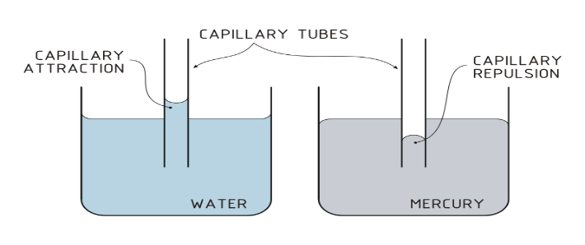

Definition: Capillarity is the depression or the rise of a liquid in a small capillary passage tube having small cross sectional area such as openings in the porous materials. Capillary action of a fluid can be experienced in both vertical and horizontal directions. In the capillarity or capillary action, the fluid moves in an upward direction against the force of gravity. It is also known as capillary action.
Examples of capillary action:
- Rise of oil through the cotton wick of oil lamp
- Rise of ink through pen nib.
- A blotting paper absorbs ink by capillary action
- Water rises from stem of tree towards the branches by capillary action.
- Water stored in earthen vessel or canvas bag oozes out of the surface because of capillary action through pores.
Derivation for surface tension by capillary rise method:
This is the oldest method used for surface tension determination.
A consequence of the surface tension appearance at the liquid/gas interface is moving up of the liquid into a thin tube that is capillary, which is usually made of glass.
This phenomenon was applied for determination of the liquid surface tension. For this purpose, a thin circular capillary is dipped into the tested liquid. If the interaction forces of the liquid with the capillary walls (adhesion) are stronger than those between the liquid molecules (cohesion), the liquid wets the walls and rises in the capillary to a defined level and the meniscus is hemispheric ally concave.
In the opposite situation the forces cause decrease of the liquid level in the capillary below that in the chamber and the meniscus is semi spherically convex.
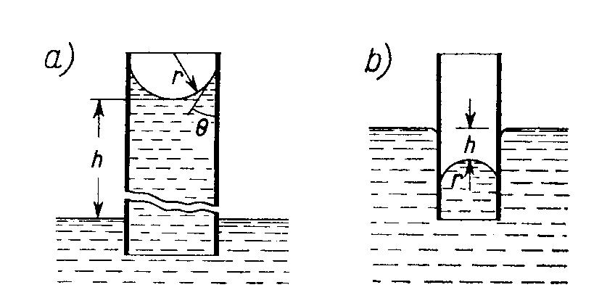

f ₁ = 2 π r γ cos θ | (1)

If the cross-section area of the capillary is circular and its radius is sufficiently small, then the meniscus is semispherical. Along the perimeter of the meniscus there acts a force due to the surface tension presence.
Where: r – the capillary radius, γ – the liquid surface tension, θ – the wetting contact angle.
The force f₁ in Eq.(1) is equilibrated by the mass of the liquid raised in the capillary to the height h, that is the gravity force f₂. In the case of non-wetting liquid – it is lowered to a distance –h.

f ₂ = π r ² h d g | (2)

where: d – the liquid density (g/cm³) (actually the difference between the liquid and the gas densities), g – the acceleration of gravity.

In equilibrium (the liquid does not moves in the capillary) f₁ = f₂ , and hence
2π r γ cos θ = π r ² h d g |  |  | (3)
Or
γ = | r h d g
 | 2 cosθ |  | (4)
If the liquid completely wets the capillary walls the contact angle θ = 0º, and cos θ = 1.

In such a case the surface tension can be determined from Eq. (5).
ᵞ=hrdg/2 (5)
P = P₁ − P₂ = d g h | (6)
P= P₁-P₂ = d g h

The balanced pressures on both sides of the meniscus.
2ᵞ/r=hdg (7)
ᵞ=hrdg/2 (8)
If the liquid does not wet the walls (e.g. mercury in a glass capillary), then it can be assumed that θ = 180º, and cosθ = -1. As the meniscus is lowered by the distance -h, Eq.(5) gives correct result Equation (50 can also be derived by using Young- Laplace equation, [ p=2ᵞ/r] from which it results that there exists the pressure difference across a curved surface, which is called capillary pressure and this is illustrated in below Fig. On the concave side of the meniscus the pressure is p₁. The mechanical equilibrium is attained when the pressure values are the same in the capillary and over the flat surface. In the case of wetting liquid, the pressure in the capillary is lower than outside it, (p₂ < p₁). Therefore the meniscus is shifted to a height h when the pressure difference p = p₂ - p₁ is balanced by the hydrostatic pressure caused by the liquid raised in the capillary.
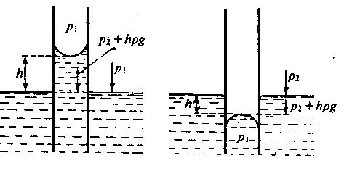

Numerical Questions
Q.1 A liquid rises to height of 2 cm in a tube of diameter 2.5 mm. How far will it rise in a tube of diameter 1.5 mm. (h₂= 3.33 cm)
Q.2 A glass capillary tube of diameter 0.02 cm is dipped into a liquid of density 0.85 × 10³ kg/m³. The liquid rises to height of 14 cm.
The angle of contact is 15⁰. Calculate the surface tension of the liquid. (T=0.06 N/m)
Q.3 The liquid rises to a height of 2.25 cm in a capillary tube of certain diameter, when the surface tension of the liquid is
6.45 × 10⁻ ² N/m. Density of the liquid is 0.9 × 10³ kg/m³ and angle of contact is 2⁰ . Calculate the diameter of tube . (r=0.0649
cm , diameter = 0.1298 cm)
Q.4 A liquid of density 1200 kg/m³ and surface tension 0.036 N/m rises to a height of 1.8 mm in a tube of radius 0.3 mm. Find the
angle of contact of the liquid. ((θ=84.93⁰)

Unit I part III
Heat : heat is the form of energy transferred between two (or more) systems or a system and its surroundings by virtue of temperature difference. The SI unit of heat energy transferred is expressed in joule (J) while SI unit of temperature is kelvin (K), and ° C is a commonly used unit of temperature.
Temperature: Temperature of a substance is a physical quantity which measures the degree of hotness or coldness of the substance. The SI unit of temperature is kelvin (K) and °C is a commonly used unit of temperature.
The two familiar temperature scales are the Fahrenheit temperature scale and the Celsius temperature scale. The ice and steam point have values 32°F and 212°F respectively, on the Fahrenheit scale and 0°C and 100°C on the Celsius scale. On the Fahrenheit scale, there are 180 equal intervals between two reference points, and on the Celsius scale, there are 100.
• If t_{c} and t_{F} are temperature values of a body on Celsius temperature scale and Fahrenheit temperature scale respectively, then the relationship between Fahrenheit and Celsius temperature is given by
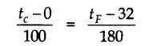
Thermal Expansion
The increase of size of a body due to the increase in the temperature is called thermal expansion. Three types of expansions can take place in solids viz. linear, superficial and volume expansion,
(i) Linear Expansion: The increase in the length of a solid on heating is called linear expansion.
If the temperature of a rod of original length l is raised by a small amount Δt, its length increases by Δl. Then the linear expansion is given by
Δl = l ∞ Δt
where a is the coefficient of linear expansion of the given solid. The unit of α is per degree Celsius (°C⁻¹) in the CGS and per kelvin (K⁻¹) in the SI system.
(ii) Superficial or Area Expansion: The increase in surface area of the solid on heating is called superficial expansion.
If A₀ is the area of a solid at 0°C and A( its area at t°C then A_{t} = A₀(l + βt)
where β is known as the coefficient of superficial expansion. Unit of β is °C⁻¹ or K⁻¹.
(iii) Volume Expansion: The increase in volume of the solid on heating is called volume expansion.
The change in the volume of a solid with a change in temperature Δt is given by Δv = V_{γ} Δt
where y is the coefficient of volume expansion.
• The relation among coefficients of linear expansion (α), superficial expansion (β) and volume expansion (γ) is given as
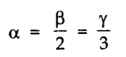
• For a given solid, the three coefficients of expansion α , β, γ are not constant. Their values depend on the temperature range.
For a given solid, the three coefficients of expansion α , β, γ are not constant. Their values depend on the temperature range.
• Liquids have volume expansion only. If we do not take into account the expansion of solid container, then the expansion of liquid is called apparent expansion. On the other hand, if we take into account the expansion of solid too, it is referred as the real expansion of liquid. It is found that γ_{r} = γ_{a} + γ_{g}, where γ_{r}= real expansion coefficient of liquid, γ_{a} = apparent expansion coefficient of liquid and γ_{g} = volume expansion coefficient of container vessel (glass).
• Water exhibits an anomalous behaviour. It contracts on heating between 0 °C and 4 °C but expands on heating beyond 4 °C. Thus, specific volume of water is minimum at 4 °C or density of water is maximum at 4 °C. This property of water has an important environmental effect.
Thermal Stress
When a rod is held between two fixed supports and its temperature is increased, the fixed supports do not allow the rod to expand, which results in a stress which is called thermal stress.
Thermal stress in the rod is given by
where Y is the Young’s modulus for the material of the rod, A is the area cross-section of the rod, a is the coefficient of linear expansion and F is the developed force in the rod.
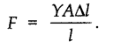
• Thermal Capacity
The thermal capacity of a body is the quantity of heat required to raise the temperature of the whole of the body through a unit degree. It is measured in calorie per °C or joule per K.
If Q be the amount of heat needed to produce a change in temperature (Δt) of the substance, then thermal capacity of the substance is given by

Dimensional formula of heat capacity is [ML²T ⁻²K⁻¹ ],
• Specific Heat Capacity
The specific heat capacity (also referred to as specific heat) of a substance is the amount of heat required to raise the temperature of a unit mass of substance through 1 °C. It is measured in cal g⁻¹(°C)⁻¹ or J kg⁻¹ K⁻¹.
The specific heat capacity of a substance is given by
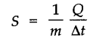
where m is mass of substance and Q is the heat required to change its temperature Δt.
• Molar specific heat capacity of a substance is defined as the amount of heat required to raise the temperature of 1 mole of the substance by 1°C.
It is given by
The unit of molar specific heat capacity is J mole⁻¹ K⁻¹ in SI system and Cal mol⁻¹ °C⁻¹ in CGS system.
The dimensional formula of molar specific heat capacity is [ML²T⁻² K⁻¹ mole⁻¹].
• Calorimetry
Calorimetry is concerned with the measurement of heat, the basic apparatus for this purpose being called the calorimeter.
When two bodies at different temperatures are ‘mixed’, heat ‘flows’ from the body at a higher temperature to the one at a lower temperature, until a common ‘equilibrium’ temperature is reached. Assuming this ‘heat exchange’ to be confined to the two bodies alone (i.e, neglecting any heat loss to the surroundings) we have, from the law of energy conservation:
Heat gained by one body = heat lost by the other.
• Transition of matter from one state (solid, liquid and gas) to another is called a change of state.
• The change of state from solid to liquid is called melting and from liquid to solid is called fusion. It is observed that the temperature remains constant until the entire amount of the solid substance melts i.e., both the solid and liquid states of the substance co-exist in thermal equilibrium during the change of state from solid to liquid.
• The temperature at which a solid melts is called its melting point. The value of melting point of a solid is characteristic of the substance and depends on pressure also.
• Melting of ice under increased pressure and refreezing on reducing the pressure is called regelation.
• The change of state from liquid to vapour (or gas) is called vaporisation. The temperature at which the liquid and vapour states of a substance co-exist is called its boiling point.
• The change from solid state to vapour state without passing through the liquid state is called sublimation.
• The Basic Heat Formula
The heat Q required to raise the temperature of a mass m of a substance of specific heat capacity s through t degrees is given by
i.e., Heat required = mass x specific heat x change in temperature
• Latent Heat
Latent heat of a substance is the amount of heat energy required to change the state of unit mass of the substance from solid to liquid or from liquid to gas/vapour without any change in temperature.
• The latent heat of fusion (L_{f}) is the heat per unit mass required to change a substance from solid into liquid at the same temperature and pressure. The latent heat of vaporisation (L_{v}) is the heat per unit mass required to change a substance from liquid to vapour state without change in temperature and pressure.
• Heat Transfer
Heat can be transferred from one place to another by three different methods, namely, conduction, convection and radiation. Conduction usually takes place in solids, convection in liquids and gases, and no medium is required for radiation.
(i) Conduction: According to Maxwell, conduction is the flow of heat through an unequally heated body from places of higher temperature to those of lower temperature. Rate of heat transfer is given by
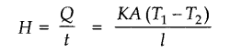
where K is called Thermal Conductivity and A is area of cross-section.
(ii) Convection: Maxwell defines convection as the flow of heat by the motion of the hot body itself carrying its heat with it.
(iii) Radiation: Radiation is the mode of heat transfer in which heat travels directly from one place to another without the agency of any intervening medium.
• Thermal conductivity is defined as heat energy transferred in unit time from unit area having a unit difference in temperature over unit length. It is expressed in Js⁻¹ m⁻¹ °C⁻¹ or W⁻¹ K⁻¹
• Thermal Resistance
The thermal resistance of a body is a measure of its opposition to the flow of heat through it. It is defined as
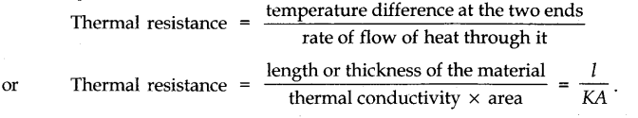
• Newton’s Law of Cooling
Newton’s law of cooling states that the rate of loss of heat of a body is directly proportional to the difference in temperature of the body and the surroundings, provided the difference in temperature is small, not more than 40 °C.
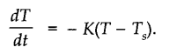
– ve sign implies that as time passes, temperature T decreases.
When an object at temperature T₁ is placed in a surrounding of temperature T₂ the net energy
radiated per second is,
